ESCAP/WMO WRD/TC.41/6
Typhoon Committee
41st Session
Chiang Mai, Thailand

Review of the 2008 Typhoon Season
Annual publications
(Item 6)

FROM MACAO, CHINA

  - Overview of tropical cyclones which have affected/impacted Member’s area in 2008

- Meteorological Assessment (highlighting forecasting issues/impacts)

Six tropical cyclones affected Macao in the calendar year of 2008, including Neoguri (0801), Fengshen (0806), Kammuri (0809), Nuri (0812), Hagupit (0814) and Higos (0817) successively. This annual number of tropical cyclones was close to the annual average of 5.65, and it was the second year with 4 tropical cyclones: Neoguri, Kammuri, Nuri and Hagupit, that necessitated the hoisting of Gale Signals No. 8 since 1993.

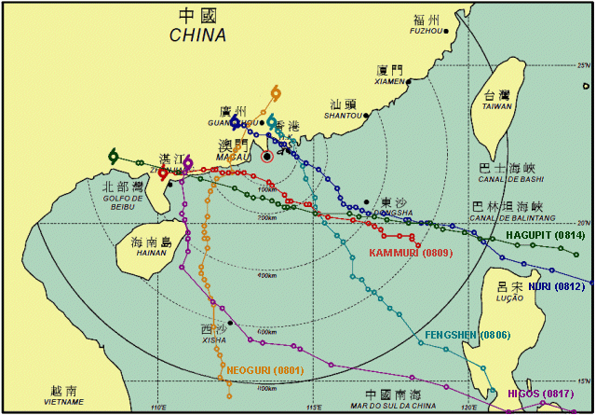

Typhoon “Neoguri”(0801)

A tropical depression developed into a tropical storm in South China Sea and was named Neoguri (0801) in the morning on 15 April 2008. As it was moving north-northwestwards, it intensified into a severe tropical storm in the morning and then a typhoon in the evening on 16 April. After passing the eastern Hainan, Neoguri weakened into a severe tropical storm and then a tropical storm on 18 and 19 April respectively, and made landfall to the east of Yangjiang in Guangdong Province on 19 April. Neoguri was closest to Macao about 100 km to the west-northwest at 19:00 L.T. on 19 April.
Neoguri was the earliest typhoon which had ever affected Macao, even before the annual “Tai Fong” Exercise scheduled and coordinated by Macao Security Forces Coordination Office. Although Neoguri was weakening during its approach to the Guangdong coastal areas, Macao was affected by its gale winds and associated rain-bands and the Gale Signal No. 8 SE was hoisted.

Date | Time* | Signal Hoisted
17/APR | 16:15 | No.1
18//APR | 20:45 | No.3
19/APR | 13:30 | Gale Signal No. 8SE
19/APR | 19:30 | No.3
19/APR | 04:00 | All signals lowered

Typhoon “Fengshen”(0806)

Fengshen intensified from a tropical depression into a tropical storm and was named on 18 June, to the southeast of the Philippines. Generally, it was moving northwestwards over South China Sea. It further developed into a typhoon to the east of the Philippines on 21 June. Fengshen was about 90 km east of Macau when it was closest at 04:00 L.T. on 25 June. It landed at Shenzhen on 25 June and dissipated on 26 June.
With the northerly air-streams constrained by the topography friction, no gale winds were recorded by AWS even it was very close to Macao. Hence, the highest signal hoisted during its passage was No. 3 only.

Date | Time* | Signal Hoisted
23/JUN | 09:30 | No.1
24/JUN | 22:30 | No.3
25/JUN | 18:30 | All signals lowered

S.T.S. “Kammuri”(0809)

On 5 August, a tropical depression intensified into a tropical storm and was named Kammuri. It was moving west-northwestwards over South China Sea. It further intensified into a severe tropical storm on 6 August about 160 km south-southeast of Macao. Kammuri was closest at about 80 km to the south-southwest of Macao at 14:00 L.T. on 6 August It made landfall near Yangjiang in Guangdong Province that evening and dissipated overland.
Slight local flooding occurred in low-lying areas of Macao and it was forecast by the storm surge model.

Date | Time* | Signal Hoisted
4/AUG | 13:00 | No.1
5/AUG | 20:15 | No.3
6/AUG | 07:00 | Gale Signal No. 8NE
6/AUG | 14:00 | Gale Signal No. 8SE
6/AUG | 20:00 | No.3
7/AUG | 04:15 | All signals lowered

Typhoon “Nuri”(0812)

On 18 August, a tropical depresson intensified into a tropical storm over Northwest Pacific and was named Nuri. It was moving west-northwestwards towards the Pearl River Delta. It further enhanced into a typhoon in the morning on 19 August over the Pacific. Nuri was closest to Macao about 60 km to the northeast at 22:00 L.T. on 22 August, and it made landfall in Hong Kong and dissipated gradually.
It was forecast that Nuri would pass Macao to the north after making landfall, and the southwesterly gale winds would replace the northwesterly. Gale Signal No.8NW was hoisted around noon and No.8SW in the evening on 22 August. Gale winds were recorded till the next morning.

Date | Time* | Signal Hoisted
20/AUG | 20:00 | No.1
22/AUG | 00:30 | No.3
22/AUG | 12:30 | Gale Signal No. 8NW
22/AUG | 20:00 | Gale Signal No. 8SW
23/AUG | 00:30 | No.3
23/AUG | 11:00 | All signals lowered

Typhoon “Hagupit”(0814)

A depression developed into a tropical storm and was named Hagupit on 19 September. It further strengthened into a typhoon to the northeast of Luzon on 21 September. Hagupit was fast moving west-northwestwards over South China Sea. It was closest at about 140 kilometers south of Macao at 23:00 L.T. on 23 September and landed in the vicinity of Dianbai County of the western Guangdong Province.
The local flooding induced by Hagupit was the most serious one since 1993 and water depth of 1.5 m above ground level was reported. On the other hand, the wind speed recorded in Macao arose from 40 km/h to 70 km/h within 2 hours in the afternoon on 23 September.

Date | Time* | Signal Hoisted
22/SEP | 22:00 | No.1
23/SEP | 13:00 | No.3
23/SEP | 19:15 | Gale Signal No. 8NE
24/SEP | 03:00 | Gale Signal No. 8SE
24/SEP | 09:30 | No.3
24/SEP | 16:00 | All signals lowered

T. S. “Higos”(0817)

On 30 September, a tropical depression intensified into a tropical storm to the southeast of the Philippines over the Northwest Pacific and was named Higos. It was moving west-northwestwards until 3 October and then veered to the north on 4 October. Higos made landfall near Wuchuan in Guangdong Province and was closest to Macao about 260 km to the west-southwest at 02:00 L.T. on 5 October.
Higos was rather unstable in both its track and its strength. Gale winds were recorded in a short period in the following day after Higos making landfall and Macao was influenced by its residual circulation.

Date | Time* | Signal Hoisted
02/OCT | 21:45 | No.1
05/OCT | 03:00 | All signals lowered

*All time mentioned above is local time

- Hydrological Assessment (highlighting water-related issues/impact)

Tropical Cyclone | Rainfall During The Signal Hoisting Period (mm) | Local Flooding  (m)
Neoguri (0801) | 98.2 - 121.6 | ---
Fengshen (0806) | 125.6 - 179.8 | ---
Kammuri (0809) | 87.2 - 100.0 | <0.5
Nuri (0812) | 82.2 - 91.6 | ---
Hagupit (0814) | 80.8 - 104.8 | Approx 1.5
Higos (0817) | 49.8 - 89.0 | ---

During the passage of Kammuri, slight local flooding occurred with water depth within 0.5 m above ground level reported.

The storm surge induced by Hagupit resulted in the most serious local flooding in Macao since 1993. Water depth of 1.5 m above ground level was reported in low-lying coastal areas that affected greatly the living of citizens, as well as tourists. Although flooding was predicted by the storm surge model and announced, the public lacked awareness or preparedness of its impact and thus great financial losses were inflicted.

- Socio-Economic Assessment (highlighting socio-economic and DPP issues/impacts)

(a) As of November 2008, not few typhoons affected Macao and led to numbers of damages in the year. Table A shown below is some damage figures caused by tropical cyclones this year. It shows obviously in the table that damages caused by Typhoon “Hagupit” are the most in terms of number and effect. “Hagupit” brought strong winds and heavy rainfall, and associated with the high tide, as a result, a lot of seawater poured into Macao and made most of low-lying coastal areas flooding. Many citizens and businesses were affected or inflicted huge financial losses.

On the other hand, there is a concern that Typhoon “Negouri” was the first tropical cyclone hit Macao this year, and was also the earliest typhoon affected Macao since last four decades. This seems to be a sign that typhoon and its relative natural disasters are changing variously in terms of the intensity, pattern as well as impacts. Therefore, some relevant government departments in Macao are having insight into these aspects, and some further actions will be taken if necessary.

Date & Time |  | Name of Tropical Cyclone | Highest  Signal Hoisted | Damages
 |  | Name of Tropical Cyclone | Highest  Signal Hoisted | Flooding | Tree | Billboard | Scaffolding | Window /Awning | Others
Start | End
18-Apr-08  16H15 | 20-Apr-08  04H00 | Neoguri  (0801) | 8 | --- | 12 | 8 | 8 | 3 | 21
23-Jun-08  09H30 | 25-Jun-08  18H30 | Fengshen  （0806） | 3 | --- | 3 | 6 | 4 | 1 | 2
04-Aug-08  13H00 | 07-Aug-08  04H15 | Kammuri  (0809) | 8 | 2 | 19 | 45 | 9 | 4 | 16
20-Aug-08  20H00 | 23-Aug-08  11H00 | Nuri  (0812) | 8 | --- | 5 | 34 | --- | 4 | 19
23-Sep-08  19H15 | 24-Sep-08  09H30 | Hagupit  (0814) | 8 | 15 | 26 | 53 | 13 | 16 | 87
02-Oct-08  21H45 | 05-Oct-08  03H00 | Higos  (0817) | 1 | --- | 2 | 1 | --- | --- | ---
Table A. Figures of damages caused by tropical cyclones in Macao within the year.

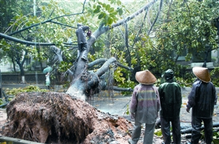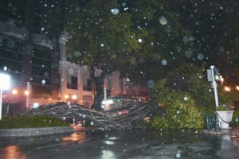
Trees blown down by strong winds during the passage of typhoon.

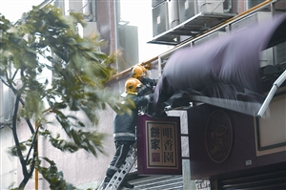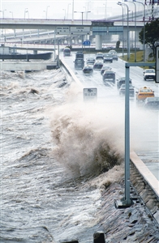

(b) The total number of damages resulted from torrential rain in Macao increased obviously this year than that in last year. According to the number of the issuances of rainstorm warning and their damages shown in the following Table B, the figures reveals that flooding and the landslip were the major impacts of heavy rainfall.
Firemen were clearing a toppling billboard.

Date | Duration | Damages
Date | Duration | Flooding | Tree | Billboard | Outer wall of building | Scaffolding | Awning | Landslip | Casualties
06-Jun-08 | 11H00-12H45 | 20 | 1 | --- | --- | --- | --- | 3 | ---
07-Jun-08 | 18H00-20H50 | 5 | 2 | 1 | --- | --- | --- | 2 | ---
25-Jun-08 | 07H10-11H10 | --- | 1 | 2 | --- | 2 | 1 | --- | ---
28-Jun-08 | 16H28-17H30 | --- | --- | --- | --- | --- | --- | 1 | ---
10-Jul-08 | 05H25-11H00 | --- | 1 | --- | --- | --- | --- | 1 | ---
11~12-Jul-08 | 22H20-02H23 | 1 | 1 | --- | --- | --- | --- | --- | ---
05-Oct-08 | 02H20-08H00 | --- | --- | --- | --- | --- | --- | --- | ---
Table B. Rainstorm warnings issued in Macao within the year and their respective damages.
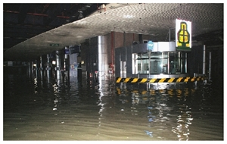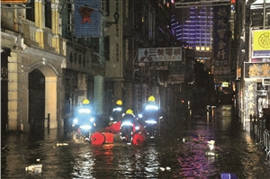
Floods and landslips caused by the combination of torrential rain and high tide during the passage of typhoon “Hagupit”.

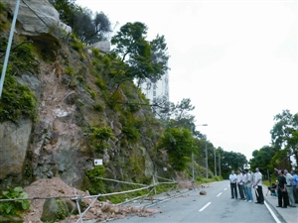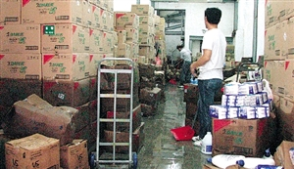

A scene in Macao during the passage of typhoon.
- Regional Cooperation Assessment (highlighting regional cooperation successes and challenges)

